|  |
| --- |
| EMBASSY OF JAPAN30 November 2018MEDIA RELEASE |

**SUCCESSFUL COLLABORATION PROGRAM MARKED WITH THE PRIVATE SECTOR FOR DISSEMINATING JAPANESE TECHNOLOGY FOR LABORATORY QUALITY MANAGEMENT SYSTEM**

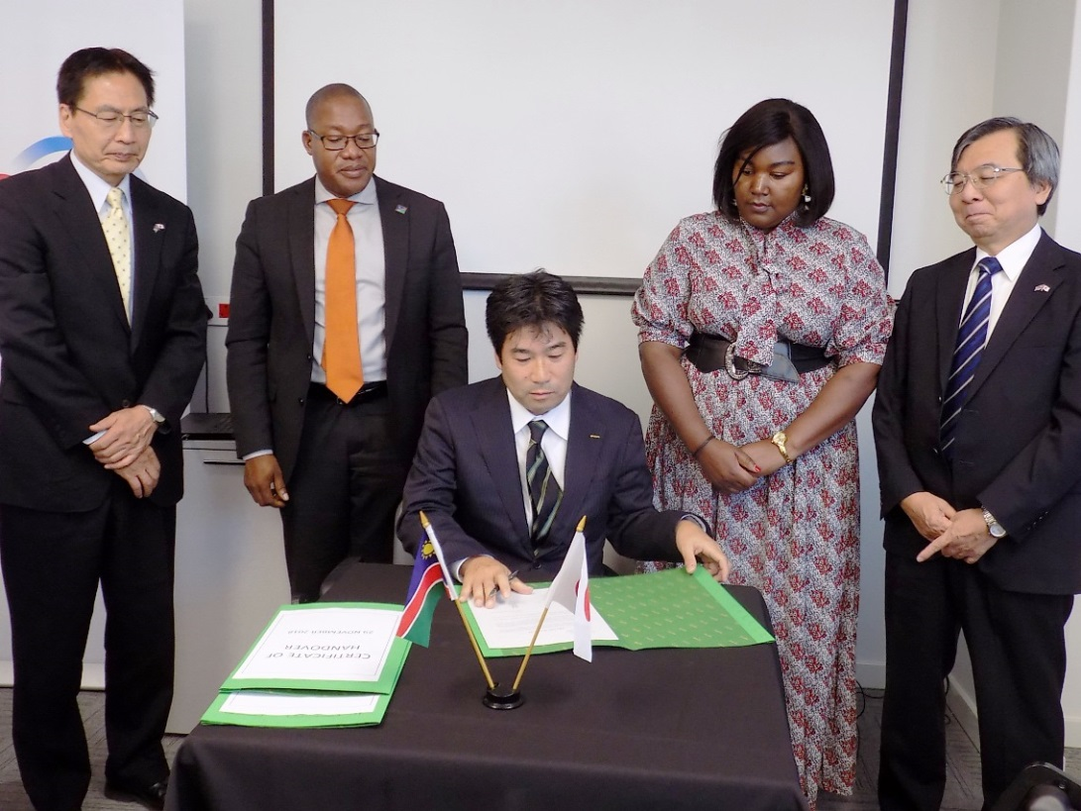

Mr. Nabeya, JICA Namibia, Mr. Nangombe, PS MoHSS, Mrs. Nghipandulwa, Acting CEO NIP, Mr. Harada, Ambassador of Japan (from the left), witnessing Mr. Yoshikawa, Sysmex Corporation, signing the hand-over certificate.

On Thursday 29th November 2018, a ceremony to mark a successful collaboration program with the private sector for disseminating Japanese Technology for Laboratory Quality Management System was held at the Namibia Institute of Pathology (NIP), with the presence of H.E. Mr. Hideaki Harada, Ambassador of Japan to Namibia; Mr. Ben T. Nangombe, Permanent Secretary of the Ministry of Health and Social Services; Mr. Shiro Nabeya, Resident Representative of JICA Namibia; Mrs. Mekondjo Nghipandulwa, Acting CEO of NIP; Mr. Kazuto Yoshikawa, Global Support Vice President, Sysmex Corporation; and Mr. Hans Hasenpflug, Managing Director, Sysmex South Africa.

The collaboration program aims to improve the quality management of the key laboratories in Namibia in order to enhance heath service delivery, as accurate and speedy disease diagnosis through clinical testing is the key for appropriate and timely treatment.

Under the program, worth approximately 2.4 million ND, the world top class technology and skills offered by the Sysmex Corporation, a Japanese leading company in clinical blood testing which operates worldwide, have been successfully transferred to the NIP laboratories, namely, the Windhoek Central Reference Laboratory, Rundu Laboratory, and Oshakati Laboratory. Three blood analysers and on-line monitoring system of the analyser operation status, the world top class products of Sysmex Corporation, have been made operational through provision of the equipment and on-site training by Sysmex experts. As proof of the successful collaboration, the Windhoek Central Reference Laboratory and Rundu Laboratory are now fully certified as quality management medical laboratories at the international standard, namely ISO15189, and that the Oshakati Laboratory is well progressing to reach the same international standard.

During the closing ceremony, three blood analysers donated by the Government of Japan through the Japan International Corporation Agency (JICA) were officially handed over to the NIP. This collaboration is one of the Government of Japan’s public-private partnership program. It aims to utilize Japanese enterprises’ technological resources, in order to effectively respond to specific development challenges, and to have a positive impact on the social welfare of a country in need.

Mrs. Nghipandulwa, in her welcoming remarks, expressed her profound gratitude to JICA, Sysmex Corporation and all stakeholders, stating that “this collaboration has brought the institution one step closer to achieving its objective. “

Mr. Hasenpflug explained Sysmex’s business model that has led this cooperation to a success. The model is to provide high quality medical equipment together with after sales support, such as continuous supply of reagents, quality control, maintenance services and training, which Sysmex realised after seeing unutilised medical equipment sold due to lack of such support.

Ambassador Harada and Mr. Nabeya both congratulated and commended the achievement made through close collaboration and partnership among NIP staff, Sysmex experts, and other partners. They also emphasised that today’s event is not the closure of the cooperation but only the beginning for further enhanced partnership, and for Sysmex Corporation to bring more world class technological resources to Namibia.

Representing the Namibian Government, Mr. Nangombe extended his appreciation to the Government and People of Japan for this cooperation. He further commended the partnership established through the program, emphasising that health services provision is, by nature, about partnership. He continued that the service would not be delivered to the people in needs on the ground only by the Ministry’s efforts. Strategic partnership with various institution and private sector, such as the one between NIP and Sysmex, is the way for Namibia to go. He concluded his remarks with his expectation that such cooperation will be further expanded beyond clinical testing.

For further information, contact Ms. Kaoru Yokotani, First Secretary of the Embassy of Japan in Namibia. Email: kaoru.yokotani@mofa.go.jp, Tel: 061-426-700/ FAX: 061-426-749.

-END OF STATEMENT-